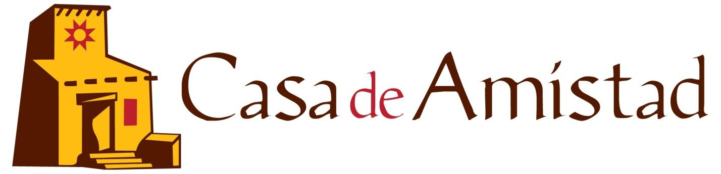
The mission of Casa de Amistad is to identify and address the needs of the under-served Hispanic community through direct service, education, advocacy and community involvement; and to create a just and harmonious, multicultural community
PO Box 841
Athens, GA 30603
athensamistad.com
706-621-5464

Job Opening: INSTRUCTOR- GED PREPARATION IN SPANISH in Athens, GA
Language Arts and Social Studies
(contractor)

Posted: July 25, 2021

Casa de Amistad is recruiting for an instructor to teach in-person and/or online classes in Spanish to prepare adults to take the General Educational Development (GED) Language Arts and Social Studies exams in Spanish.

Casa de Amistad is a local non-profit in Athens-Clarke County area that works with and for the local Latinx/Hispanic and immigrant population.

Classes are currently planned to continue in an online format. We seek instructors who are able to offer both in-person and digital classes, depending on changing pandemic conditions. The safety of our students and instructors is paramount.

Casa offers GED preparation classes at no cost to adults who range across the age spectrum and bring varying educational, cultural, literacy, occupational, and life experiences/skills to the class. Our adult students are often juggling work, family, and other responsibilities in addition to attending class. They may need some support with getting set up online, and the online teaching methods used will take into account the devices (mostly smart phones) and internet availability that our adult students typically have.

Therefore, the person who takes this position will be an enthusiastic, compassionate person who understands and enjoys meeting the special challenges faced by immigrant adults, some of whom may not have extensive formal education. The instructor must be able to establish a respectful, supportive, safe, and enjoyable environment that values what each student brings to the classroom as well as helps them acquire the needed language arts and social studies skills needed to pass the GED.

The instructor must be comfortable dealing with simple digital technology and willing to take responsibility for learning and adapting methods to remote teaching.

Preferred instructors have at least a Bachelor’s degree, experience with the GED, and experience teaching adults in a community setting, or other comparable combinations of certifications and experience.

We currently anticipate classroom sessions of 1 hour each, three times a week, at least two of which will take place during the weekday evening hours of 7:00 to 8:30 pm. Class offerings and schedules may be expanded, depending on funding availability. Classes generally follow a fall and spring semester format of 15 weeks/semester.

For more information, please see our website at www.athensamistad.com

To Apply: Email a resume or CV, plus a cover letter addressing your qualifications for the job to: Stephanie Paladino at athensamistad@gmail.com with “GED Instructor ” in subject title. Please provide contact information for up to three references. Questions about the position can also be mailed to the same address. Applicants must be willing to pass an E-Verify check.

